**LIST OF FIGURES**

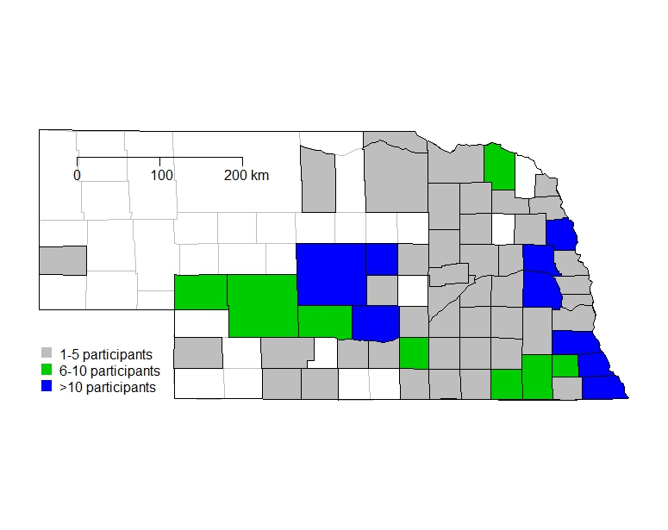

Figure 1. Nebraska counties represented in the survey. Different colors represent the number of respondents per county. The soybean production area of Nebraska is concentrated in the east, central and southern parts of the state.



Figure 2. Herbicides tank mixed with dicamba sprayed POST in dicamba-resistant (DR) soybeans in Nebraska expressed as % Respondents and % ha. Complete responses (Q7-9 Table 1B) from 63 farmers representing a total of 9,098 ha of DR soybean sprayed with dicamba were used to generate this figure.



Figure 3. Likelihood (logistic model; red line) of dicamba off-target injury in non-dicamba-resistant (DR) soybean fields in response to dicamba application time (day of the year; x-axis) in DR soybean. The model was fitted to the responses from 30 participants (Q 11, Table 1C).